Lab 2 – Security Applications
By Federico Jahns
Part 1 (Connect Lab 1 to Port Scanning)
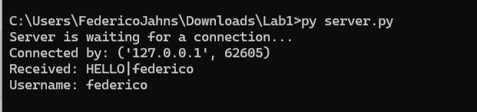
Part 2 (New Python Concepts)
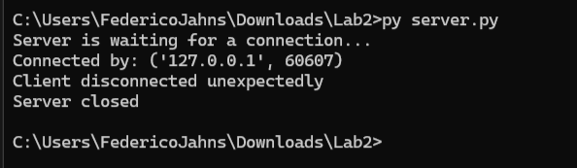\
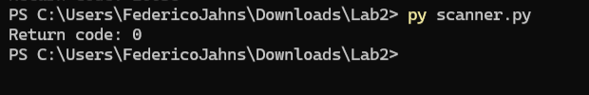
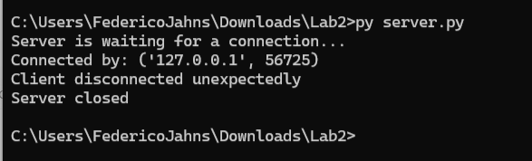
Part 3 (Test ONE Port First)
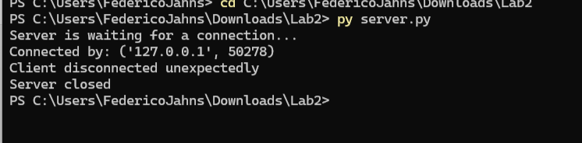
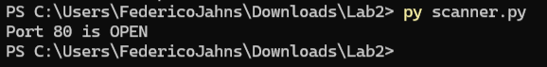
Part 4 (Turn ONE Port Test into a Function)
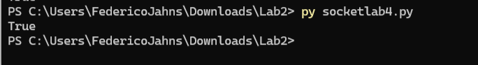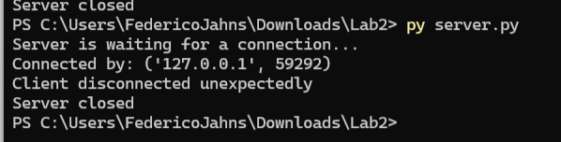
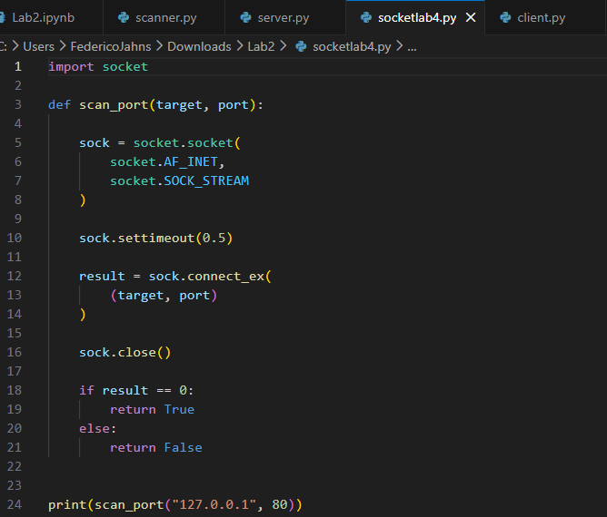
Part 5 ( Scan a Small Range of Ports)
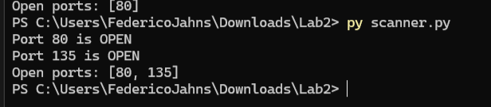
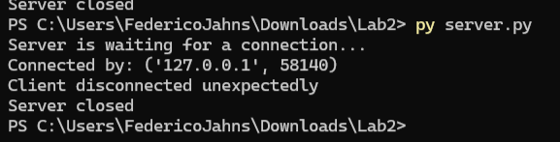
Part 6 (Identify Likely Services)
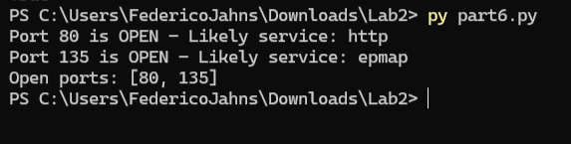

Part 7 (Accept User Input)
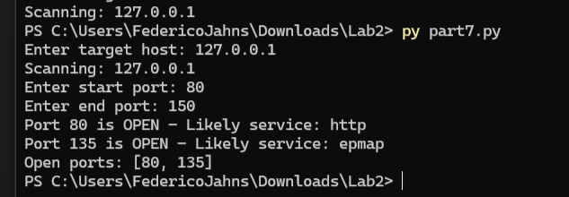
Part 8 (Validate the Port Range)
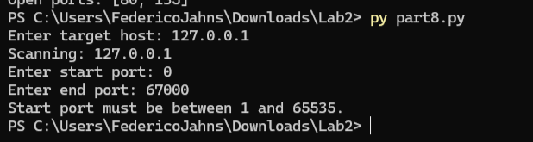
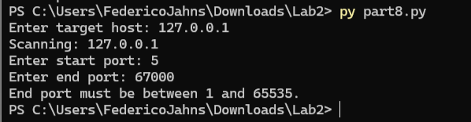

Part 9 (Build the Computer Scanner)
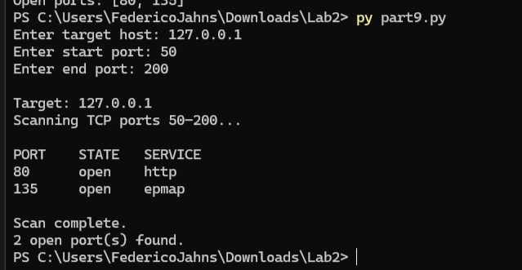
Part 10 (Robustness test)
- Invalid hostname
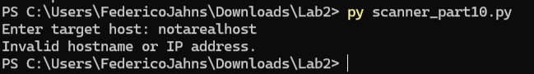
- Non-numeric ports
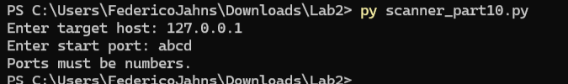
- Start Port greater than end port
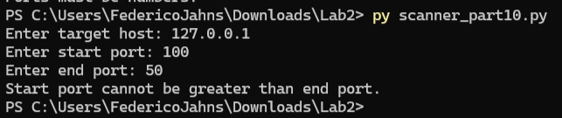
- Port above 65535
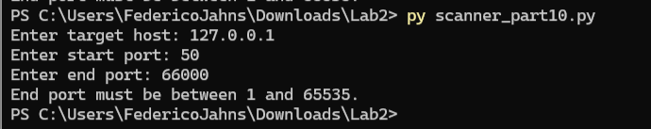

Part 11 (Compare your Scanner with Nmap)
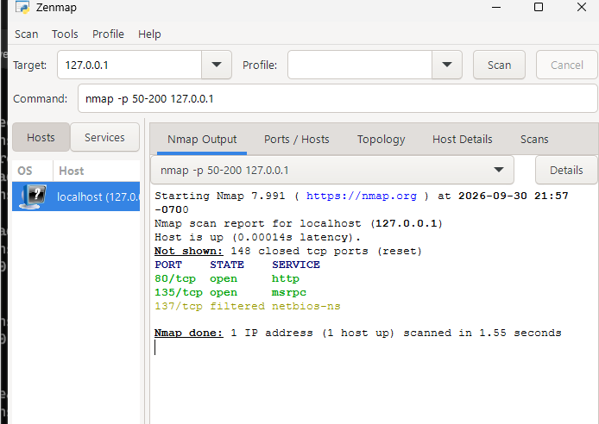
Answer:
- Did Nmap Identify the same open ports as your python scanner?
Yes, both my python scanner and Nmap scanner identified the ports: 80 and 135 opened on 127.0.0.1 as the host.
- What additional information did Nmap provide?
The Nmap scanner provided detailed information on the state of the ports along with the number of closed TCP ports (148) along with verification that the host was up. In addition to this service names such as http, msrpc were included.

- Did Nmap distinguish states that your scanner could not?
Yes, Nmap distinguished states between open, closed and filtered ports. The python scanner within the lab primarily sees whether a tcp connection has succeeded or not so it can not reliably filter the state or service of the ports.
- Why is your python scanner useful for learning even though Nmap is more capable?
Within the lab, the python scanner is useful for learning because it shows how TCP scanning works and has me demonstrate my understanding through execution and experimentation of the scripts provided. Nmap process most of this on its own with little user interaction.

Part 12 (Rebuild your scanner using python -nmap)
Step 1 – Install python -nmap
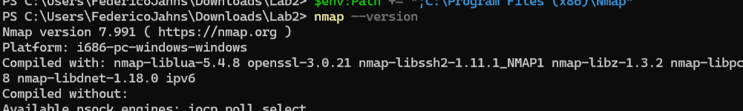
Step 2 - Import the library
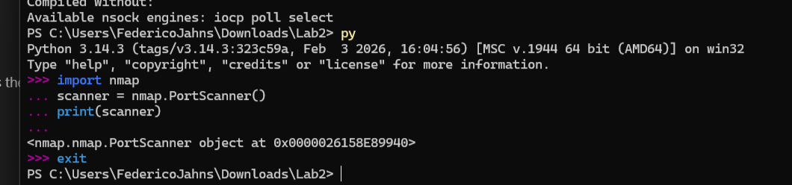
Step 3 - Create a PortScanner object

Step 4 – Perform a small authorized scan
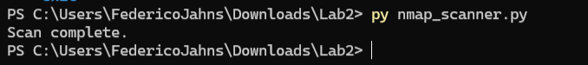
Step 5 – Explore the results
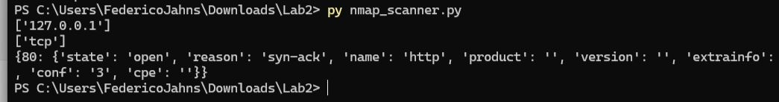
Think about it – How is this information different from your raw socket scanner returned?
This information is different because nmap returns a much more detailed answer in comparison the raw socket scanner previously. The Raw socket scanner mainly states if a TCP connection is done or not while NMAP shows port information, making NMAP more capable than basic scanners.
Step 6 – Build nmap_scanner.py
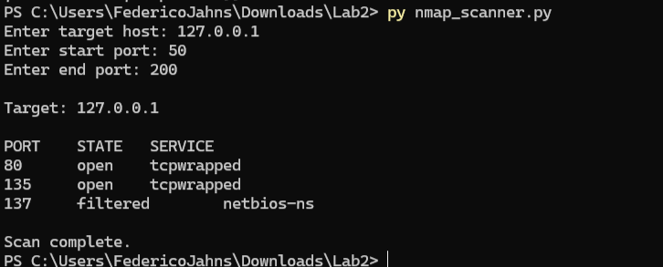
- Which version required more code?
The raw socket version used in this lab required more code because manual socket were needed along with set timeouts and restrictions for connection attempt, closed sockets and port management.
- Which version provided more information?
The Python-nmap version in the lab provided more information than the raw socket because it returned port states, services and nmap results.
- What information did Nmap provide that your raw socket scanner did not?
Nmap provided additional information such as port states: open, closed or filtered and service details.
- What work is python -nmap hiding from the programmer?
Python-nmap is hiding much of the low-level processes and micromanaging that takes place when launching nmap and organizing the results.
- Why was it useful to build the raw socket version before using python-nmap?
Building the raw socket version was useful before the python-nmap because it shows the logic behind port scans and how socket, timeouts and restrictions play an important role in such tools.
- If you were developing a real security application, which approach would you choose and why?
If I were to develop a real security tool application, I Would approach it with nmap because it provides more detailed scan results and isn’t too complicated to use.

Part 13 (security reflection)
- What information can an attacker learn from port scanning?
An attacker can learn the service type along with which ports are open and closed.
- Why can an open port increase a systems attack surface?
An open port increases a systems attack surface by allowing malicious actors to gain access to certain aspects of the network.
- Does an open port automatically mean a vulnerability exists?
An open port does not automatically mean a vulnerability exists because services or network activity could be intended solely for said port as part of the configuration.
- Why should unnecessary network services be disabled or restricted?
Certain network services should be disabled or restricted because it reduce the potential attack surface for malicious actors to access.
- What is the difference between an open port and a closed port?
An open port has a service that is listening and accepting connections where as a closed port does not have said service to accept connections.
- Why might a firewall make scan results difficult to interpret?
A firewall can make scan results difficult to interpret because it may block or drop packets depending on the rules set in place along with having conflicting port states or services.
- Why can our simple TCP Connect scanner not reliably identify every filtered port?
The TCP Connect scanner can not reliably identify every filtered port because it primarily checks whether a connection has succeeded or failed and the cause behind a failure if it occurs.
- How could defender detect or limit scanning activity?
Defender can detect or limit scanning activity by using firewalls or any form intrusion detection along with network monitoring to detect malicious activity.
- Why should defender scan their own systems?
Defenders should scan their own systems because they can discover and amend unsecure ports, unrequired services and network issues before a malicious actor can exploit them first.
- Why is authorization important before performing network scanning?
Authorization is important before performing a network scan because scans have the potential to violate certain policies depending on the scope that security workers are allowed to work in along with the capabilities of the tools at use.

Part 14 (Security Analysis)
The authorized target that was scanned was the localhost ip 127.0.0.1. A controlled TCP port range from ports 50 to 200 was used within the lab. The python socket scanner was able to identify ports 80 and 135 as part of the server.py. Port 80 was associated with the likely service http while port 135 was associated with the likely service epmap. When comparing those results with the ones taken from Nmap, Nmap was able to identify ports 80 with HTTP and 135 as MSRPC with both ports being open, along with their service and an additional port: 137 as filtered. In addition to this nmap reported that 148 ports within the range were closed.

Some difference observed between the nmap and python scanner were that the python scanner was able to show connections processes directly. Socket were created and used with applied timeouts and validation for a successful TCP connection. Nmap however, provided additional information such as port state, service and filtering.

From a defender’s perspective, these results particularly the state of the ports show a possibility for malicious actors to exploit entry points into the system. However, an open port does not necessarily mean it is a vulnerability since it could be running for specific connections in the network or configuration, but it still poses a risk. Outdated services or misconfigured ports can allow an attacker to use it as a means of reconnaissance into a vulnerable system and expand from there. Port 80 is usually used for HTTP so if no web service is running then it creates unnecessary exposure to web related attacks. Port 135 is associated with windows related communication so it should also be restricted when not in use.

To mitigate unnecessary exposure, some defensive measures include the disabling of services not in use along with restriction policies and firewall rules along with periodic port scans and network monitoring to ensure all behavior is normal. Frequent checkups and scans can ensure that security and system configurations are working properly.

